DATA DISTRIBUTION
Data distribution
The way data values are spread out or distributed
Two common types:
Uniform distribution:
- All values have equal chance of occurring.
- Example: rolling a fair die → each number (1–6) is equally likely.
- Function: np.random.uniform(low, high, size)
where: low = start, high = end and size = no . of random numbers
Example:
x=np.random.uniform(0.0,5.0,250)
plt.hist(x,50,color=’skyblue’)
→ generates 250 random numbers between 0 and 5, all equally likely.
Normal distribution(Gaussian):
- Bell-shaped curve — most data values cluster around the mean.
- Common in nature (height, weight, IQ, etc.)
- Function: np.random.normal(mean, std_dev, size)
mean : most of the generated numbers will be close to this value
standard deviation: tells us how spread out the data is
- small std_dev -> numbers tightly packed near mean -> bell curve looks tall and narrow
- large std_dev -> numbers loosely packed near mean -> bell curve looks wide and flat
Example:
x=np.random.normal(5.0,2.0,10000)
plt.hist(x,100,color=’indianred’)
→ mean = 5.0, standard deviation = 2.0, 10000 random samples.
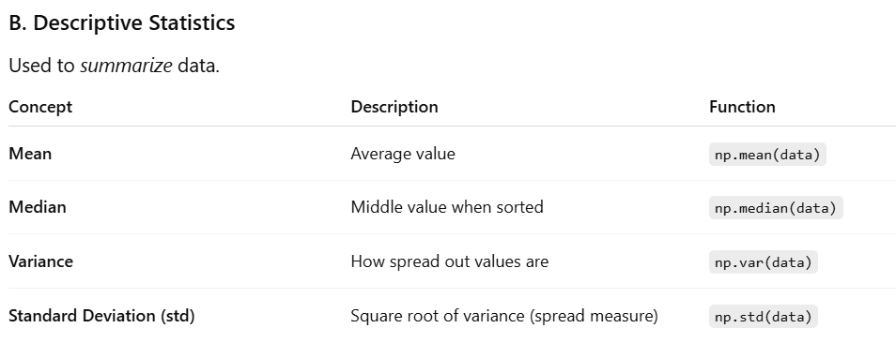
** standard deviation is the avg distance from mean (just the sq root of variance)
** variance formula:
$$σ^{2}=\frac{∑{\left(x_{i}-μ\right)}^{2}}{N}$$

Scatter Plot
x=np.random.normal(5.0,1.0,500)
y=np.random.normal(10.0,2.0,500)
plt.scatter(x,y,color='indianred',alpha=0.5,s=100)

Regression
The term regression is used when you try to find the relationship between variables.
In Machine Learning, and in statistical modeling, that relationship is used to predict the outcome of future events.

Linear Regression
Linear regression uses the relationship between the data-points to draw a straight line through all them.
This line can be used to predict future values.

import matplotlib.pyplot as plt
import numpy as np
from scipy import stats

x=[10,20,30,50,40]
y=[1,2,3,4,5]

slope, intercept, r, p, std_err = stats.linregress(x,y)

def myfunc(x):
return slope * x + intercept

mymodel=list(map(myfunc,x))

plt.scatter(x,y,color='hotpink')
plt.plot(x,mymodel,color='teal')

print(r)
print(p)
print(std_err)
print(slope)
print(intercept)

linregress() fits a straight line to your data — of the form:
y = slope × x + intercept
It also gives you some statistics about that line.

- slope - how much y changes with each value of x
- intercept - the value of y when x=0
- r - correlation coefficient (R-value) how strongly x and y are related (ranges from -1 to 1)
- p - how likely is it that your observed relationship between x and y happened by pure chance
- luck - no real linear relationship
- unlikely luck - real linear relationship
- std_error - how accurate the slope estimate is

